**LAB CYCLE – 2**

**PROGRAM NO : 01**

**Aim:**

**Create a string from the given string where the first and last character are exchanged.**

**[ Eg: python => nythonp]**

**Source Code:**

**str=input("Enter a string:")**

**new_str=str[-1]+str[1:-1]+str[0]**

**print("New String : ",new_str)**

**Output:**



**________________________________________________________________________________**

**PROGRAM NO : 02**

**Aim:**

**Get a string from an input string where all occurences of the first character are replaced with ‘$’ , expect the first character.**

**[Eg: onion => oni$n]**

**Source Code:**

**str=input("Enter a string which has reoccurence of first character:")**

**firstchar=str[0]**

**newstr=firstchar+str[1:].replace(firstchar,'$')**

**print("New String : ",newstr)**

**Output:**



**________________________________________________________________________________**

**PROGRAM NO : 03**

**Aim:**

**Create a single string separated with space from two strings by swapping the character at position 1. Eg : str1 = “Hello” str2 =”World” , then create a string str3 = “Hollo Werld” [Hint: use slicing and concatenation ]**

**Source Code:**

**str1=input("Enter the first string:")**

**str2=input("Enter the second string:")**

**newstr=str1[0]+str2[1]+str1[2:]+" " +str2[0]+str1[1]+str2[2:]**

**print("New String : ",newstr)**

**Output:**



**________________________________________________________________________________**

**PROGRAM NO : 04**

**Aim:**

**Count the number of characters (character frequency) in a string.**

**Source Code:**

**str=input("Enter a string:")**

**a=len(str)**

**print(f"The numnber of characters in the string {str} is {a}")**

**Output:**



**________________________________________________________________________________**

**PROGRAM NO : 05**

**Aim:**

**Add ‘ing’ at the end of a given string. If it already ends with ‘ing’, then add ‘ly’**

**Source Code:**

**str=input("Enter a string:")**

**if str.endswith(‘ing’):**

**newstr=str+"ly"**

**else:**

**newstr=str+"ing"**

**print("New String : ",newstr)**

**Output:**



**________________________________________________________________________________**

**PROGRAM NO :06**

**Aim:**

**Store a list of first names. Count the occurrences of ‘a’ within the list.**

**Source Code:**

**str1=input("Enter the first name of first person:")**

**str2=input("Enter the first name of second person:")**

**str3=input("Enter the first name of third person:")**

**str4=input("Enter the first name of fourth person:")**

**str5=input("Enter the first name of fifth person:")**

**l=[str1,str2,str3,str4,str5]**

**count=0**

**for i in l:**

**for j in i:**

**if j=="a":**

**count+=1**

**print("The occurence of 'a' within the list of these first names is ",count)**

**Output:**

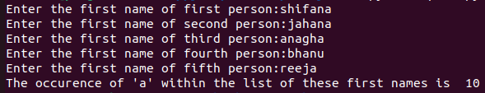

**________________________________________________________________________________**

**PROGRAM NO : 07**

**Aim:**

**Write a python program to read two lists color-list1 and color-list2. Print out all colors**

**from color-list1 not contained in color-list2.**

**Source Code:**

**a=int(input("Enter the number of colours to be inserted in first list of colours:"))**

**colour_list1=[]**

**for i in range(a):**

**colour_list1.append(input("Enter the name of a colour:"))**

**print("The first list of colours is:",colour_list1)**

**b=int(input("Enter the number of colours to be inserted in second list of colours:"))**

**colour_list2=[]**

**for i in range(b):**

**colour_list2.append(input("Enter the name of a colour:"))**

**print("The second list of colours is:",colour_list2)**

**result_list=[]**

**for i in colour_list1:**

**if i not in colour_list2:**

**result_list.append(i)**

**print("The colors from first list not contained in second list are:",result_list)**

**Output:**

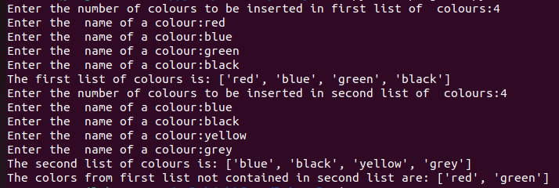

**________________________________________________________________________________**

**PROGRAM NO : 08**

**Aim:**

**Create a list of colors from comma seperated color names entered bt the user. Display first and last colors.**

**Source Code:**

**colors=input("Enter the name of colours seperated by commas:")**

**colors=colors.split(',')**

**color_list=[]**

**for i in colors:**

**color_list.append(i.strip())**

**print("The list of colours is:",color_list)**

**if color_list:**

**print("First Colour:",color_list[0])**

**print("Last Color:",color_list[-1])**

**else:**

**print("No colors entered")**

**Output:**

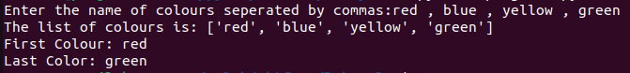

**________________________________________________________________________________**

**PROGRAM NO : 09**

**Aim:**

**Write a program to prompt the user for a list of integers. For all values greater than**

**100,store ‘over’ instead.**

**Source Code:**

**numbers=input("Enter a list of integers seperated by spaces:")**

**a=numbers.split()**

**l=[]**

**for i in a:**

**l.append(int(i))**

**print("List:",l)**

**newlist=[]**

**for i in l:**

**if i>100:**

**newlist.append('Over')**

**else:**

**newlist.append(i)**

**print("New List:",newlist)**

**Output:**



**________________________________________________________________________________**

**PROGRAM NO : 10**

**Aim:**

**From a list of integers, create a list after removing even numbers.**

**Source Code:**

**numbers=input("Enter a list of integers seperated by spaces:")**

**a=numbers.split()**

**l=[]**

**for i in a:**

**l.append(int(i))**

**print("List:",l)**

**newlist=[]**

**for i in l:**

**if i%2!=0:**

**newlist.append(i)**

**print("New List:",newlist)**

**Output:**



**________________________________________________________________________________**

**PROGRAM NO : 11**

**Aim:**

**Accept a list of words and return the length of the longest word.**

**Source Code:**

**words=input("Enter a list of words seperated by spaces:")**

**a=words.split()**

**l=[]**

**for i in a:**

**l.append(i.strip())**

**print("The list of words is:",l)**

**max_len=-1**

**long=[]**

**for i in l:**

**if len(i)>max_len:**

**max_len=len(i)**

**print("Length of longest word: ",max_len)**

**Output:**



**________________________________________________________________________________**

**PROGRAM NO : 12**

**Aim:**

**Write a program to prompt the user to enter two lists of integers and check**

**(a) Whether lists are of the same length.**

**(b) Whether the list sums to the same value.**

**(c) Whether any value occurs in both Lists.**

**Source Code:**

**number1=input("Enter integers seperated by spaces which is to be inserted to first list:").split()**

**l1=[]**

**for i in number1:**

**l1.append(int(i))**

**number2=input("Enter integers seperated by spaces which is to be inserted to second list:").split()**

**l2=[]**

**for i in number2:**

**l2.append(int(i))**

**print(f"First List: {l1}\nSecond List: {l2}\n(a)")**

**print("Length of first list: ",len(l1))**

**print("Length of second list: ",len(l2))**

**if len(l1)==len(l2):**

**print("Both lists are of same length")**

**else:**

**print("Both lists are not of same length")**

**sum1=0**

**sum2=0**

**for i in l1:**

**sum1+=i**

**for i in l2:**

**sum2+=i**

**print("(b)\nSum of elements of first list: ",sum1)**

**print("Sum of elements of second list: ",sum2)**

**if sum1==sum2:**

**print("The sum of elements of both the lists are equal")**

**else:**

**print("The sum of elements of both the lists are not equal")**

**bothlist=[]**

**for i in l1:**

**if i in l2:**

**bothlist.append(i)**

**print("(c)")**

**if bothlist:**

**print("The value occurs in both the lists are:")**

**for i in bothlist:**

**print (i)**

**else:**

**print("There is no value occurs in both the lists")**

**Output:**

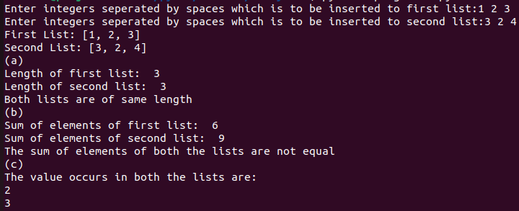

**________________________________________________________________________________**

**PROGRAM NO : 13**

**Aim:**

**Write a Python program to count the occurrences of each word in a line of text.**

**[Hint: use split() function and dictionary]**

**[Sample input : the quick brown fox jumps over the lazy dog**

**Output : {'the': 2, 'jumps': 1, 'brown': 1, 'lazy': 1, 'fox': 1, 'over': 1, 'quick': 1, 'dog.': 1}]**

**Source Code:**

**line=input("Enter a line of text:").split()**

**l=[]**

**for i in line:**

**i.lower()**

**l.append(i)**

**print("The list of words in this line of text is:",l)**

**d=dict()**

**for i in l:**

**if i in d:**

**d[i]=d[i]+1**

**else:**

**d[i]=1**

**for i in d:**

**print(f"The number of occurence of {i} : {d[i]}")**

**Output:**

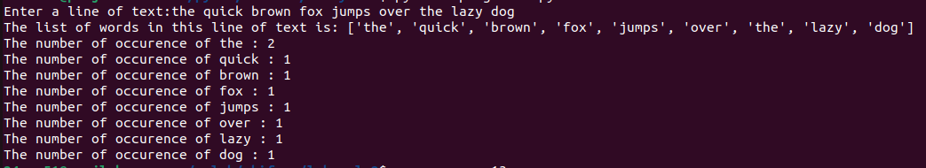

**________________________________________________________________________________**

**PROGRAM NO : 14**

**Aim:**

**List comprehensions:**

**(a) Generate positive list of numbers from a given list of integers**

**(b) Square of N numbers(c) Form a list of vowels selected from a given word**

**(d) Form a list ordinal value of each element of a word (Hint: use ord() to get**

**ordinal values)**

**Souce Code:**

**print("(a)")**

**num=input("Enter a list of integers seperated by spaces:").split()**

**l=[]**

**for i in num:**

**i=int(i)**

**if i>0:**

**l.append(i)**

**print("List of numbers containing only positive numbers:",l)**

**print("\n(b)")**

**square=[]**

**n=int(input("Enter a limit to find the square of numbers:"))**

**for i in range(1,n+1):**

**square.append(i**2)**

**print(f"List containing the square of first {n} numbers : {square}")**

**print("\n(c)")**

**word=input("Enter a word:")**

**vowel=[]**

**for i in word:**

**if i in ['a','e','i','o','u']:**

**vowel.append(i)**

**print(f"List of vowels selected from the word {word} is {vowel}")**

**print("\n(d)")**

**w=input("Enter a word:")**

**ordinal=[]**

**for i in w:**

**ordinal.append(ord(i))**

**print(f"List of ordinal value of each element of the word {w} is {ordinal}")**

**Output:**

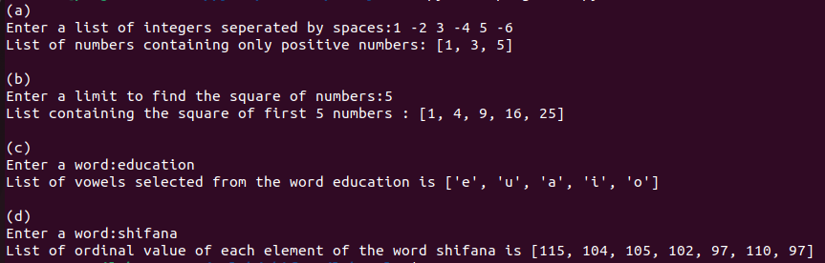**________________________________________________________________________________**

**PROGRAM NO : 15**

**Aim:**

**Sort dictionary in ascending and descending order.**

**Source Code:**

**d={'orange':2,'banana':3,'apple':5}**

**asc=dict(sorted(d.items()))**

**desc=dict(sorted(d.items(),reverse=True))**

**print("Dictionary :",d)**

**print("Ascending Order :",asc)**

**print("Descending Order :",desc)**

**Output:**



**________________________________________________________________________________**

**PROGRAM NO : 16**

**Aim:**

**Merge two dictionaries.**

**Source Code:**

**d1={'a':1,'b':2}**

**d2={'b':3,'c':4}**

**print("First Dictionary : ",d1)**

**print("Second Dictionary : ",d2)**

**d1.update(d2)**

**print("Merged Dictionary : ",d1)**

**Output:**



